1 Create an SQL statement that lists all managers and their title

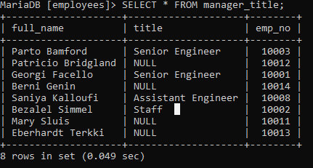

Analysing the data I think this should be returning 8 rows, however it is only returning 4. On further inspection of the tables I can see that the titles table seems to have errors, with duplicated employee numbers (emp_no), there are also 14 employees and only 11 rows for title, so 3 employees are missing titles. Statement updated to allow for NULLS.

2 Create a SQL statement to show the salary of all employees and their department name.

Again in this case there is missing information, only 7 employees are accounted for in the dept_emp table meaning only 7 employees are listed in the joined table furthermore there is a duplicate employee number in the salaries table meaning there are only 7 valid entries (8 entries in total, 1 unaccounted for). Statement updated to allow for NULLS. Employee ID 10001 also has 2 differing salaries associated with them

3 Create a SQL statement to show the hire date and birth date who belongs to HR department.

(alternatively for the WHERE statement; WHERE d.dept_name = 'Human Resources'

I had to choose the information from two seperate tables 'dept_manager' and 'dept_emp' as they were the only tables that had human resources members in there. The table 'titles' has no human resource member, facilitating the need for 2 INNER JOINS and a UNION to two tables to gather all the relevent information.

4 Create a SQL statement to show all departments and their department’s managers.

Some departments are missing managers and others have more than one manager in the dataset, so not every department is accounted for. Also many people listed as managers are also listed as employees based on their employee numbers - some are also tied to multiple departments.

5 Create a SQL statement to show a list of HR’s employees who were hired after 1986

The people listed as HR employees all have hire dates starting later than 1986 according to the employees table, however the start date is different according to the 'from_date' columns so I am using the 'from_date' from the respective dept_emp and dept_manager tables as I assume they may have changed roles and become a HR employee later.

6 Create a SQL statement to increase any employee’s salary up to 2%. Assume the employee has just phoned in with his/her last name.

7 Create a SQL statement to delete employee’s record who belongs to marketing department and name start with A

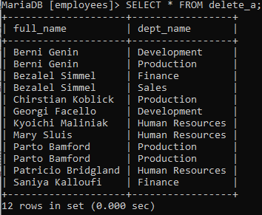

8 Create a database view to list the full names of all departments’ managers, and their salaries.

In this case, we can only return the rows for which the employee ids match, meaning a lot of manager salaries are not accounted for and because of a duplicate ID one row is being returned twice.

9 Create a database view to list all departments and their department’s managers, who were hired between 1980 and 1990.

The BETWEEN statement doesn't allow for null values on the date, I have looked into adding and IsNull condition to the statement however it hasn't worked yet.

10 Create a SQL statement to increase salaries of all department’s managers up to 10% who are working since 1990.

